Name: K S Pavan Krishna

USN: 1MS17IS051

Sem:6

COMPUTER GRAPHICS ASSIGNMENT

**Q>Define pixel,voxel,cga,vga,svga?**

**ANS>Pixel:** In digital imaginary,a pixel is a single point in a

raster image.The pixel is the smallest addressable screen

element.It is the smallest unit of picture that can be con-

trolled.The address of a pixel is it’s own co-ordinates.

Each pixel is a sample of an original image,more samples

provided more accurate representation of the original.

The number of pixels in an image is called resolution.

Pixels are used as a measure of resolution(dpi,ppi).

**VOXEL:**A voxel is a volume element representing a value

On a rectangular grid in 3D space.As with pixels in a bit-

map, voxels do not have their position encoded with their.

The position of a voxel is based on a position of relative to other voxel.It is good at representing regularly-sampled,

Homogeneously filled visualization and analysis.

**CGA:** Color graphic adapter introduced in 1981.It was IBM’s

First color graphics card and the first color computer display standard for Pc.The standard IBM CGA was equipped with 16Kb

Of video memory and cold be connected either to a NTSC compatible monitor or TV via an RCA jack.

**VGA**:Video graphics array refers specifically to the display hardware introduced with IBM in 1987.It has a resolution of 640*480.VGA was the last graphical standard introduced by IBM.VGA was supersided by numerous extensions of VGA collectively called as Super VGA.

**SVGA:**It is a broad term that covers wide range of computer display system standards.Svga refers to a resolution of 800*600 pixels.It’s first version called for 4-bit pixels.It was expand to 1024*768 8bit pixels.

**Q>Explain Z-buffer algorithm with neat sketches?**

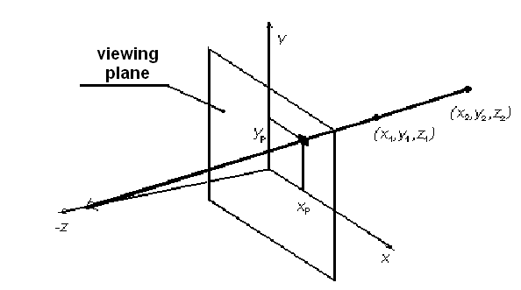

Z-buffer algorithm is also called depth-buffer algorithm.

For each pixel on the screen,we record the depth of the object within the pixel that lies closest observer.Also,we record the intensity that should be displayed to show the object.This algorithm requires 2 arrays:INTENSITY and DEPTH each of which is indexed by pixel co-ordinates(x,y).

**ALGORITHM:**1>For all pixels,set DEPTH(x,y) to 1.0 and intensity (x,y) to a background value.

2>For each polygon in the scene,find all pixels(x,y) that lie within the boundaries of the polygon when projected onto the screen.For each of these pixels:

a>Calculate depth z of the polygon (at [x,y])

b>If z<DEPTH(x,y),this polygon is closer to the observer and therefore,set DEPTH(x,y) to z and intensity(x,y) to a value corresponding to the polygon’s shading.

c>If z>DEPTH(x,y) to a value corresponding to the polygon is farther from observer and no actions is taken.

At surface position (x,y),depth is calculated from the plane equation as

Z =-Ax-By-D/C

**LIMITATIONS OF Z-BUFFER ALGORITHM**

* The Z-buffer algorithm is not always practicable because of the enormous size of the depth and intensity arrays.
* Even through a frame buffer may provide memory for the intensity array,the depth array remains large.
* To reduce the amount of storage required the image can be divided into many smaller images and the Z-buffer algorithm is applied to each in turn.
* Subdivision of screen reduces the work required to generate the iage due to wherence between small regions of the screen.It has given rise to a nuber of scan-line algorithms.